2023 NACS / NASE Zones C & D Meeting
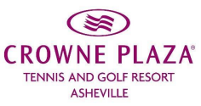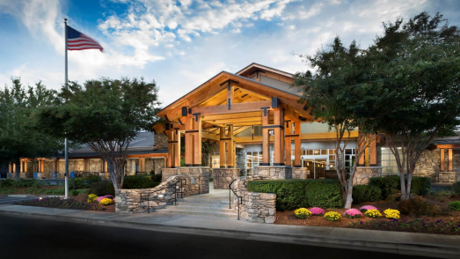
1 Resort Drive, Asheville NC 28806
$119 plus tax/night. Rooms are a mix of King and Two Queen beds. Rates are for single and double occupancy based on availability at the time of inquiry and are subject to change.

Reservation deadline is 12 pm EST, January 24, 2023!!

To make reservations, you have the following options:

- Use the following link: NC Association of Credit Specialists (Sorry, not mobile compatible)
- Access: www.ashevillecp.com. Enter dates of your stay, and use Group Code: ACS
- Call toll-free number 1-844-330-0296 (24/7) and mention the group NC Association of Credit Specialist in order to receive the special group rate.
NOTE: This rate available for 2 days before conference and 2 days after, so that you may enjoy the many attractions and activities that Asheville has to offer!

If you wish to stay an additional day or more, you will need to call the hotel to make your reservation: Desiree @ 828-285-2603 or Emma @ 828-285-2620

Room Features:
• Complimentary Wi-Fi
• 43 inch flat panel television
• Private patio or balcony
• Refrigerator
• Fitness Room as well as complimentary use of Asheville Racquet Club located on-site
• Complimentary Parking
• The Crowne Plaza sleep advantage package

Pets are permitted with permission of resort – $25/night. Contact resort for details.

Shuttle Services:
• Airport: A discounted rate of $45.00 for the first person and $10.00 for each additional person, one way to Asheville Regional Airport is available. Hotel transportation to and from the Airport must be arranged with the Front Desk. Flight times and arrangements must be provided at least seven (7) days prior to arrival.
• Downtown: $8.00 per person round-trip shuttle to and from three center city locations.

Hotel Amenities & Services
• Complimentary High Speed Wireless Internet
• Complimentary Self-Parking
• Fitness & Wellness Center
• Walking and Running Trails
• No Resort Fee
• On Site Business Center
• Sixteen outdoor and four indoor tennis courts
• Adelaide Spa
• Asheville Treetops Adventure Park
• One indoor saline lap pool
• Overlook Restaurant and Lobby Bar: Our full service restaurant offers breakfast, lunch and dinner daily. The Lobby Bar opens at 4:00pm daily serving cocktails and lite fare menu.

GETTING HERE

Located at the center of two major interstates and home to an airport offering direct flights from major hubs, getting to Asheville is uncomplicated for meeting attendees.

DRIVE
Asheville is centrally located in the southeast. Atlanta-based attendees can drive to Asheville in approximately 3 1/2 to 4 hours. From Columbia, SC the drive time is approximately 2 hours and 20 minutes. Nashville, TN is approximately a four-and-a-half-hour trip. Charlotte, NC is a 2-hour drive, and Raleigh, NC is approximately a four-hour trip.

FLY
The Asheville Regional Airport (AVL) is located just 20 minutes from downtown. Click for detailed flight travel information. And, once you get here, you are surrounded by the region’s highest peaks, national parks, state forests and the famed Blue Ridge Parkway. The wide-open spaces and deep cultural connections make it a hidden gem outside densely populated areas — but within a 600-mile radius of 50 percent of the country’s population.

Things to do while in Asheville:

Biltmore Estate: Biltmore in Asheville North Carolina Visit America’s largest home. Finished in 1895, the 175,000 sq. ft. home contains 250 rooms and sits on an 8,000 acre estate. Guided and self-guided tours are available, purchasing tickets in advance is recommended.
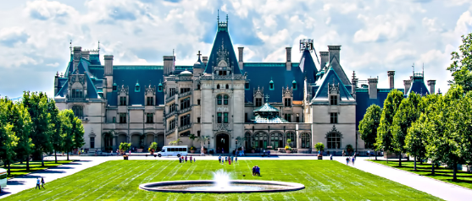

Breweries: Asheville is known for its arts & crafts and outdoor activities, but is also famous for its number and variety of craft breweries. With over 100 breweries located in Asheville and surrounding mountains, and close to 50 in the Asheville city limits, there are plenty of neat places to check out.
Asheville Ale Trail Fall/Winter 2022-2023 by Hulsey Media - Issuu
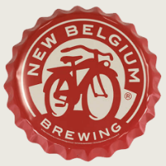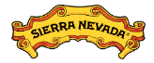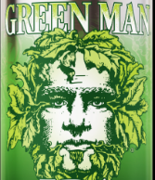

Omni Grove Park Inn: If you have some extra time, it is worth a visit to the Grove Park Inn. This luxury hotel, built in 1913 and host to ten US Presidents, provides a beautiful overlook of Asheville and the Blue Ridge Mountains. The lobby’s stonework and two 14’ fireplaces are worth the trip. The Omni Grove Park Inn | Resorts in Asheville, North Carolina (omnihotels.com)

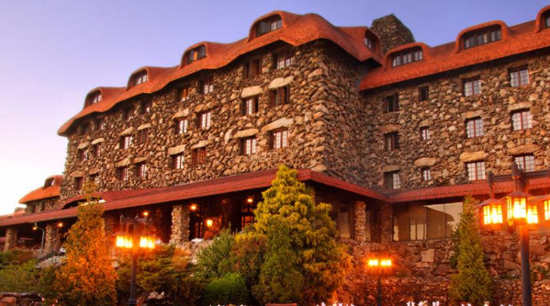

Restaurants:

Pack’s Tavern – 20 S. Spruce St.

White Duck Taco Shop – 12 Biltmore Ave.

Barley’s Taproom & Pizzeria – 42 Biltmore Ave.

Twisted Laurel – 130 College St.

Strada Italiano – 27 Broadway St.

Shopping:

Mast General Store – 15 Biltmore Ave.

Ten Thousand Villages in Asheville – 10 College St.

Grove Arcade – 1 Page Ave.

French Broad Chocolate Lounge – 10 S. Pack Square

Activities:

Off The Wagon Dueling Piano Bar – 22 N. Market St.

Asheville Pinball Museum – 1 Battle Square

Botanical Gardens at Asheville – 151 WT Weaver Blvd.

