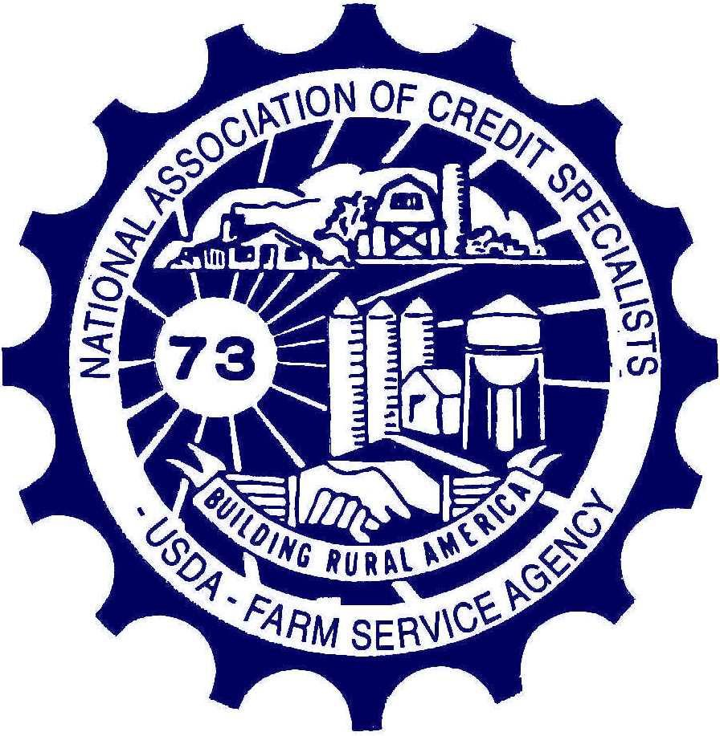

NACS 2021-2022
State Presidents Guide

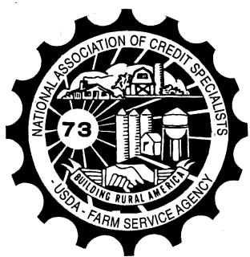
Building Rural America

National Association of Credit Specialists
of the

USDA – Farm Service Agency

TABLE OF CONTENTS

Statement of Principles 3
NACS Board Member Directory 4
NACS Committee Members 6
NACS-FSA Key Events 7
NACS Constitution & By-Laws 8
State Associations 10
Key Practices 10
Relationship of the State Association with the State Executive Director and the State Office 11
Guidelines for the Consultative Relationship between the (State) Association of Credit Specialists and the State Office of the Farm Service Agency 12
NACS Consultative Agreement 14
NACS Resolutions 15
Membership 16
Preparing to Host a Zone Meeting or National Convention 18
Zone Meeting 18
National Convention 22
Forms – Resolution Form 23
Committee Survey 24
Expense Voucher 25
Membership Packet 26

Statement of Principles
The purpose of this organization, the National Association of Credit Specialists of USDA, Farm Service Agency is one of the highest of ideals. The main objective is to establish a professional organization made up primarily of managers to expand, improve, and expedite the services of Farm Service Agency to rural America.

We want to promote the social, economic, professional and vocational skills, civic and personal welfare of all USDA Farm Service Agency employees to:

- Ensure equal status and privileges with other federal and non-federal employees.
- Improve morale and efficiency by giving suitable recognition both to individual employees and to USDA Farm Service Agency field offices whose performances are outstanding.
- Collect and disseminate information relating to the above and to use such information for the general good without favoritism, bias, or prejudice.

Our organization is designed to look at the way we do business and make suggestions along with solutions for improvement of our agency and program delivery. The resolution process is critical to our goal of improving the delivery of our programs. It is through this process that mutual respect is recognized when we consult with the National Office in Washington, D.C.

We will strive to improve our working conditions, provide adequate staffing for our offices, obtain better equipment and technology, and to establish a consultative relationship at policy making levels to bridge the gap between policy makers and field employees. We cannot be effective in these areas unless we speak from a position of strength. Strength comes from numbers. We need the support of every field employee who is involved in the credit delivery system. We need some of your time, encouragement, and a little of your money. This organization will not be effective unless you are behind it 100%. We solicit your support and encourage your active participation in either attending your Zone Meetings, National Convention, or serving on a special task force or committee to represent members of the National Association of Credit Specialists.

Mission Statement
To enhance the delivery of FSA programs through facilitation of communication and interaction between FSA field level employees and FSA senior level management.

NACS Board Member Directory

President  Kim Eilerman | 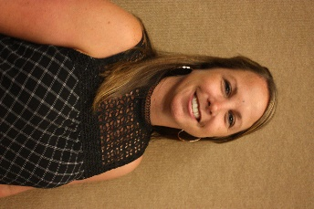 | Work  604 E Franklin Ave  Jerseyville, IL 62052  618-498-6836 x3103  kimberly.eilerman@usda.gov | Personal  3424 N Mississippi River Rd  Batchtown, IL 62006  217-248-0526  kim_sfs@hotmail.com
Vice President  Ben Herink | 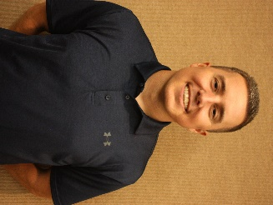 | Work  7131 A Street  Lincoln, NE 68510  402-437-5886  ben.herink@usda.gov | Personal  5394 W Katleman Dr.  Lincoln, NE 68521  402-416-9096  bherinkqb@hotmail.com
Secretary  Jessica Weigand |  | Work  100 Sun Ave, Ste 200  Albuquerque, NM 87109  505-761-4930  jessica.a.weigand@usda.gov | Personal  15 Colby Ct  Edgewood, NM 87015  720-272-9478  jess.ann.smith23@gmail.com
Treasurer  Ray Bartholomew | 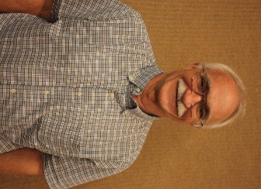 | Work  18 E 7th Ave  South Hutchinson, KS 67505  620-669-8266  ray.bartholomew@ks.usda.gov | Personal  4107 South Obee Road  Hutchinson, KS 67501  620-200-8253  raybart53@gmail.com
Past President  LeAnn Gibbs |  | Work  100 Sun Ave NE, Ste 200  Albuquerque, NM 87109  505-761-4932  lisa.gibbs@usda.gov | Personal  10348 Pintura Pl NW  Albuquerque, NM 87114  575-693-6358  thre3gees@gmail.com
Zone A Rep.  Amy  Dykema | 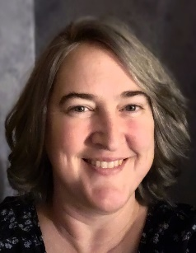 | Work  54059 Hwy 2 West, Suite 1  Glasgow, MT 59230  406- 228-4321  amy.dykema@usda.gov | Personal  PO Box 1185  Glasgow, MT 59230  507-360-3748  adykema92@gmail.com
Zone B Rep.  Lisa Liska | 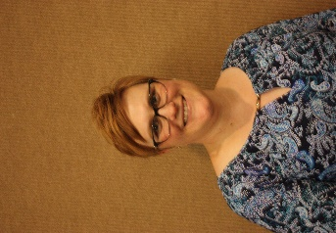 | Work  7131 A Street  Lincoln, NE 68510  402-437-5456  lisa.liska@usda.gov | Personal  8450 Cody Drive, Apt 318  Lincoln, NE 68512  402-984-0686  lisahofmann@live.com
Zone C Rep.  Nathan  Adams | 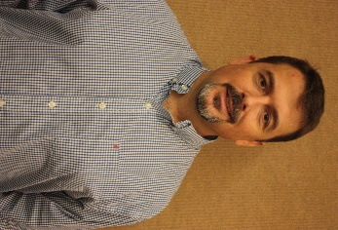 | Work  252 South Ridgewood Dr  Rockville, IN 47872  765-569-3551  nathan.adams@in.usda.gov | Personal  99 South Wabash Rd  Montezuma, IN 47862  765-562-2368  nathanadams1@hotmail.com
Zone D Rep.  Millicent Harrison |  | Work  1030 Peach Parkway Suite 4 Fort Valley, GA 31030  478-827-0016 X 3138  millicent.harrison@usda.gov | Personal  9000 Watson Blvd Apt 706 Byron, GA 31008  478-235-5019  millicentharrison24@gmail.com

NACS ZONE ALTERNATES

Zone A – Vacant | Zone B – Kaiti Steckman, NE
Zone C – Vacant | Zone D – Amber Brown, NC

NACS Committee Members

*Chairperson, **Vice Chair

FLP – Loan Making | Member | Alternate
Zone A | *Rebecca Padilla, NM | Ana Gallegos-Cain, NM
Zone B | Whitney Serrano, TX | Mickelle Storr-Munnings, TX
Zone C | Anthony Williams, VA | Anna Wooley, KY
Zone D | Nicole Cleggs-Burns, AL | Chana Thompson, AR
FLP – Loan Servicing | Member | Alternate
Zone A | Chantal Haun, CA | Katherine Lewis, CA
Zone B | *Irby McWilliams, TX | Kelli Luebbert, NE
Zone C | Tiffany Grody, OH | Nathan Denney, KY
Zone D | Tonya Washington, AR | Matthew Christian, TN
Information Technology (IT) | Member | Alternate
Zone A | Becky Gerlach, WY | Jessica Davis, ID
Zone B | Amy Dykema, MN | Cristina Escobedo, TX
Zone C | Vicki Swift, KY | Kristin Clapp, KY
Zone D | *Dana Baucom, TN | Sara Harris, GA
Legislative | Member | Member
Zone A | Casey Toyne, CO
Zone B | Ben Herink, NE
ZoneC | **Brandon Waldron, VA | MaryBeth Tomika, KY
Zone D | *Dave Bonnett, NC | James Jackson, AL
Management & Personnel | Member | Alternate
Zone A | Jessica Smith, NM | John Oosterman, CA
Zone B | Eric Mortimer, TX | Heather Cox, TX
Zone C | *Juanita Ballman, KY | Carol Nagel, WI
Zone D | Theresa Windham, GA | Alec Love, MS
Membership | Member | Alternate
Zone A | Annette Peters, CO | vacant
Zone B | *Lisa Liska, NE | vacant
Zone C | Crystal Zwilling, IL | Amanda Robertson, KY
Zone D | Charlean Smith, AR | vacant

NACS-FSA Key Events

Activity | Date
Send list of State Officers to Zone Representative & NACS Secretary | At time of change
Send date of State Meeting to Zone Representative | When set
Send Quarterly Dues to NACS Treasurer; send changes to State Treasurer to NACS Secretary and NACS Treasurer | June 1st, September 1st, December 1st, March 1st
National Officers meet with National Office | Fall
Committees meet with National Office | Fall
National Board meets with National Office | Spring
Zone A Meeting – | First weekend of March  *Alternate Second weekend of March (A&C)
Zone B Meeting – | First weekend of February  *Alternate Third weekend of February (B&D)
Zone C Meeting – | Fourth weekend of February  *Alternate Second weekend of March (C&A)
Zone D Meeting – | Second weekend of February  *Alternate Third weekend of February (D&B)
National Convention – | Last week of June (tentative)
Key dates and events are also available at the NACS web site at www.nacs-fsa.org, select Events.

*Zones may use alternative weekend for their meetings in the event they are not able to secure accommodations for their meeting in the weekend designated. Under no circumstances will there be two Zone meetings scheduled for the same weekend. In the event a Zone is unable to secure accommodations for their designated weekend, the hosting State will notify the Zone Representative, the Zone Representative will notify the Association President.

NACS Constitution & By-Laws
Excerpt from the Constitution…

ARTICLE III – MEMBERSHIP
  - Membership shall consist of four kinds:

    - REGULAR - regular membership shall be those employees, not including political appointees, involved in agricultural credit services that have supervisory and/or program management responsibilities and/or whose job responsibilities include primary duties of agricultural credit programs technical support, which pay quarterly dues and agree to abide by the Constitution and By-Laws of this Association. – Revised at NACS Convention, New Orleans, 2019.
    - ASSOCIATE - All individuals who have an interest in the objectives of the Association but do not qualify for regular membership, who pay dues and agree to abide by the Constitution and By-laws of this Association.

    - RETIRED - All retired employees of the USDA Agencies shall be eligible for retired membership by payment of lifetime dues and agreeing to abide by the Constitution and By-laws of this Association.

    - HONORARY - Any person who the Board of Directors shall recommend and receive a 2/3 vote from the official delegates at the annual meeting.

  - Regular membership only, shall carry with it the privilege of holding any office to which they may be elected or appointed and can represent their state if appointed a delegate and have voting privileges on matters brought before the Association.

  - To qualify for membership in the National Association, an individual must be a member of a State Association or a duly recognized Association of Credit Specialists working in a state, regional or national office.

ARTICLE IV – GOVERNMENT
- OFFICERS
Officers of this Association shall be a President, Vice President, Secretary and Treasurer, who shall hold office for one year, or until their successors are duly elected and qualified.

- BOARD OF DIRECTORS
The Board of Directors shall consist of the newly elected officers, the retiring president and the zone representatives.

- The four officers and past president shall be the executive committee.

- Manner of Election

1. Each state or duly recognized association in good standing on the first day of the national convention shall be entitled to the following delegates and alternates based on the regular membership in the respective association:

Membership | Delegates | Alternates
1-10 | 3 | 3
11-25 | 4 | 4
26-40 | 5 | 5

41 - + | 6 | 6

Membership shall be shown by the records of the National Association Treasurer as of the first day of the National Convention. Selection of each delegate and alternate shall be evidenced by a certificate signed by the President or Secretary of each state or recognized association.

Excerpt from the By-Laws…

ARTICLE I - DUES AND FISCAL YEAR
- Annual dues shall be determined by the Board of Directors.

  - State may pay dues either annually or quarterly. State paying dues annually, must pay in advance versus arrears.

  - States paying quarterly shall have their dues due and payable in alignment with the NACS fiscal year.

    - Dues shall be due and payable on June 1st, September 1st, December1st and March 1st.

- The fiscal year shall be June 1 to May 31.

Important Notes…

Dues as set by NACS board as of May 19, 2021
- National NACS Dues are $144 per year
- Associate National NACS Dues are $30 per year
- National Lifetime Membership is $100, paid one time
- National NACS Dues are $52 for any first-time member who joins between June 1, 2021 and May 31, 2022

Potential Members
NACS-FSA consists of the following FSA state and county employees: Farm Loan Managers, Farm Loan Officers and Trainees, District Directors, Farm Loan Specialists including Appraisers and Underwriters, Farm Loan Chiefs, Loan Analysts, any other FSA employee classified in the GS-1165 series, and any FSA employee who deals primarily and directly with Farm Loan program management responsibilities or who has supervisory responsibilities for Farm Loan programs.

The full NACS CONSTITUTION AND BY-LAWS may be reviewed at: www.nacs-fsa.org

State Chapters

Key Practices
- Check NACS web site weekly for updates (www.nacs-fsa.org).
- Meet quarterly or as provided by your consultative agreement with the State Executive Director/State Committee.
- Request that a representative participate on Merit Promotion Panels.
- Request time on district and state meeting agendas to discuss Association concerns.
- Sponsor an awards program for members and friends.
- Hold an annual State Association meeting.
- Utilize committees in your state to develop policies and provide input on resolutions and meetings.
- Prepare your state to host a Zone Meeting or National Convention.
- Have the State President and others attend the Zone Meeting. The National Association will provide a stipend to assist with travel expenses. This will be sent to the State Treasurer for each state that has a member attend their zone meeting.
- Have the State President and delegates attend the National Convention. The National Association will provide partial reimbursement for any National Committee member from your state. First time attendees may also be eligible for partial reimbursement; also, new members that are first time attendees will be eligible for a second drawing at the discretion of the board.
- Utilize the news media to publicize activities and recognize individuals.
- Send periodic newsletters using non-government email systems to membership. Forward all National and Zone newsletters to all members using non-government systems.
- Have your State send delegates to Washington, D.C. as needed or requested by NACS Board to carryout Legislative activities. Encourage members to be on a first name basis with their U.S. Senator and Representative. Information regarding bills before Congress can be obtained at www.house.gov or www.senate.gov.
- Have the State Treasurer forward to the NACS Treasurer dues on a quarterly basis according to the NACS constitution. The State Treasurer should also submit a list of members (paid and free) in the format designated by the NACS Treasurer.
- Keep your Zone Representative posted on activities in your state by sending them a copy of your state’s newsletter.
- Notify the NACS Secretary after the election of new state officers and send the Secretary the names and addresses of new board members.
- Submit resolutions to Committee Chair at the Zone Meeting or at least two weeks prior to the National Convention.
- DO NOT USE GOVERNMENT computers to communicate NACS, State Association or various legislative issues to members or others, unless authorized by management.

Relationship of the State Chapter with the State Executive Director and the State Office
The State Chapter should strive to have a close, well-coordinated working relationship with the State Executive Director (SED) and State Office staff. It is the responsibility of the State President to establish the communication needed by the State Chapter in working with the SED. It is very important that the President have the ability to be a leader in all phases of the Association as well as FSA.

It is the responsibility of the State President to approach the SED to establish regular meetings with the SED on a quarterly basis or at the request of either the SED or the State President. The State President should make his request for a yearly meeting of the board with the SED by letter including an agenda and asking the SED for any items they would like to add to the discussion.

When the Board meets with the SED, it is very important that the membership be requested to provide input to the Board. It is also a good idea for the President to ask for input and to let members know of the results of the meetings with a newsletter. The Board and President must motivate the membership to ensure the membership is represented at every level.

The State Chapter is the voice of its members, and the National Association is the voice for the State Chapters. The National Board depends on the State Chapter to provide information about what issues affect credit delivery in different states. It is important that the National Board be well informed to be able to represent all of its members to the FSA National Office management.

Whenever there is a problem within a state, either within the Chapter or the State Office, the State Chapter officers should contact the Zone Representative and advise the National Association Board. The Zone Representative can work with the State Executive Director and State Chapter President to help resolve any problems and keep the National Association President informed of any meetings and their outcome. The Zone Representative can work with the State Chapters to increase the membership and help the state have a more meaningful working relationship with the SED and the National Association Board. The Zone Representative can be a very important link between the states and the National Association.

The newsletters, non-government email and the NACS website are the best way to keep members informed of current issues and the results of meetings. Communication is the key! A clear channel of communication between all parties is necessary to be effective. The National Board needs to know what the issues are, and the members need to know how the Board is addressing the issues. Communication is also the key to a good working relationship between the SED and the State Chapter.

If the National Association can help the State Chapter in any way, please contact a board member whose name and number are listed in this guide or at the NACS website (www.nacs-fsa.org).

Guidelines for the Consultative Relationship between the (State) Association of Credit Specialists and the State Office of the Farm Service Agency
The guidelines are hereby promulgated as part of the FSA program for intra-management communication and consultation. This agreement shall be consistent with the Section 251 of the Federal Personnel Guidelines.
These guidelines evidence our belief that a cooperative relationship between the State Office and the State Chapter strengthens FSA. They are based on the premises that mutual benefits accrue from providing increased avenues of communication and consultation, and that the members of the Association are part of the FSA management team. It is not the intent of the Association to become or act in the capacity of a union.

CONSULTATION:
  - The Association will be given an opportunity to consult with the State Executive Director (SED) on substantive personnel and program policy changes within the SED’s authority in areas of:
    - Improvement of FSA operations;
    - Improvement of working conditions;
    - Improvement of managerial effectiveness; and
    - Establishment of policies that best serve the public interest in accomplishing the mission of FSA.
  - The Association shall consider and furnish recommendations on matters which the SED or the Association President identifies as needing solutions.
  - The President of the Association, or the President’s designee, will represent the Association on the following committees:
    - Position Management Committee
    - Incentive Awards Committee
    - Other “Management” Committees established by the SED.

MEETINGS
The following meetings are authorized and planned to be held according to the following schedule:
A. The officers will meet with the SED and or other State Office Personnel semi-annually (Tentatively scheduled for November and May, subject to final approval by the SED.)
- The officers, district representatives, and past president will meet with the SED and other State Office Personnel semi-annually (Tentatively scheduled for February and August, subject to final approval by the SED.)
- The State President or the President’s designee will attend each State Staff Meeting.
- The State President, or the President’s designee, and the National Officers will be allowed I day of official time to attend the Zone Meeting. Attendance is subject to the prior approval of the SED, who will grant approval if the work situation in the employee’s office permits.
- The official delegates, National Board members, and each member of a committee of the National Association is granted 2 days official time to attend the NACS annual meeting. The granting of official time is subject to the prior approval of the SED, who will grant approval if the work situation in the employee’s office permits.

- Any other meetings that may be deemed appropriate or necessary by the SED. This may include, but is not limited to:
  - For the purpose of identifying solutions for specific FSA problems affecting the field.
  - Task force membership. (i.e., program, personnel, financial, etc.).

SERVICES
  - Official time will be authorized for Association Officers and district representatives for communication in such areas as:
    - Preparing comments and responses to higher management on “consultative relationship” items or other items of mutual benefit.
    - Preparing newsletters or other written communications to members to inform them of decisions of higher management and other items of mutual benefit and concern; and
    - Contacting Association Officers and members of the board of directors on items of consultation, problems or conditions to be brought to the attention of management.
  - In carrying out the functions of the State Association that are authorized in item III A, the following services are authorized:
    - Use of office support personnel for clerical and typing assistance.
    - Use of FSA stationary, envelopes and official postage.
    - Use of Federal Telecommunications System. If FTS is not available, use of commercial facilities are authorized; however, the official ethics and standards will still apply.
    - Use of FSA reproduction and internal distribution systems. A copy of all material to be reproduced and distributed will be sent to the SED.
    - Use of file cabinets and office equipment.
    - National office proposed policy issuances will be passed on by the SED to officers of the Association for comment when such policies will have a major impact on the employees’ operations.

PERIOD:

A. This agreement shall continue in effect from the date signed until a revised or new agreement is prepared and signed by the SED and President of the State Association of Credit Specialists.

State Executive Director | Date |  | President | Date

NACS Consultative Agreement
Excerpts…

SECTION 2 OFFICIAL TIME AND USE OF FACILITIES

- AGENCY SPONSORED MEETINGS

Official time, travel, and per diem is approved for any meeting called by the agency to work on agency business for the benefit of the service.

- ANNUAL NACS-FSA CONVENTION

2 days of official time is authorized for each member of the NACS-FSA Board of Directors and State Delegates to attend the annual convention.

Official time to attend annual NACS-FSA convention shall be cleared in advance through the employee’s supervisor.

No travel and per diem is authorized for the annual NACS-FSA convention.

- ANNUAL ZONE MEETINGS

Official time is authorized for NACS-FSA state representatives to attend NACS-FSA zone meetings as follows: 1 day for 1 State NACS-FSA representative to attend a zone meeting for their area.
Official time to attend zone meetings shall be cleared in advance through the employee’s supervisor. No travel and per diem is authorized for annual zone meetings.
9. OTHER USE OF OFFICIAL TIME

Official time is authorized for official agency business only. Internal NACS-FSA business such as the solicitation of membership, collection of dues, election of officers, preparation of newsletters, etc. shall be conducted during non-duty hours of the employees involved.

- DUES WITHHOLDING

NACS-FSA members are authorized to effect voluntary allotment for the payment of dues to NACS-FSA, subject to requirements of the National Finance Center. (FSA 444)

The FULL National Association of Credit Specialists-FSA (NACS-FSA) Consultative Agreement with Farm Service Agency (FSA) may be found at www.nacs-fsa.org or in National Handbook 3-PM, Exhibit 35

NACS Resolutions

Overview of the Resolution Process
The resolution process begins with each NACS member. Resolutions are the backbone of existence for NACS. Members should be encouraged to submit resolutions using the online process established on the NACS web site. After the conclusion of the convention the final adopted committee report will be submitted to the respective National Administrators. The committees will discuss the returned report with the various representatives and the final report with all comments will be posted to the NACS FSA website.

Objectives: The purpose of the resolution database is to accomplish the following:
  - Provide a single place for members to submit resolutions.
  - Allow other members to view submitted resolutions throughout the year, to involve more members in the process and obtain differing points of view.
  - Provide for a uniform method of printing out resolutions so all committees have the same format, look and feel

Submit resolutions as follows: (www.nacs-fsa.org)
- Under the Committees section, select the appropriate committee
- Click on the Submit a Resolution button
- Complete the data fields as appropriate. When finished entering your resolution select Submit to send the resolution.

Resolutions may also be submitted in writing at Zone Meetings and the National Convention by using the NACS Resolution Form found on the at www.nacs-fsa.org under documents / forms or the form in the back of this guide.

NACS Technical Forum
In consultation with DAFLP a forum, to address technical items such as misspelled words, missing references and any other basic technical corrections, has been established on USDA Connect.
Submission of a resolution that falls into this category will be reposted to this forum by the FLP and/or IT committee to which the original resolution was submitted.

NACS-FSA Committee Survey
NACS Committee members are appointed by the NACS President to serve a one-year term that ends after the next convention. Committee members are selected based on their interest, initiative and willingness to work.
Committee service will require a good deal of your time, effort and some personal financial expense. Attendance at meetings with the agency may be needed to discuss resolutions. Legislative Issues committee members are expected to attend the legislative initiative activities in WDC as necessary and requested by the NACS Board. Service may also be needed to work on special topics such as task forces, etc. Alternate committee members assist the primary member in each zone.

To assist in the appointment process, the committee survey is distributed to all members, especially those in attendance at the National Convention. This survey indicates your interest. If you are not selected for a primary or alternate committee position, this information will also be used, as needed, to select members to serve on special NACS committees and task forces throughout the year.

The committee survey may be submitted on line at www.nacs-fsa.org under Committees – Sign up for committees. The form may be found under documents on the same website as well as in the back of this guide.

Membership

Building NACS - Building Rural America

Objective: To establish a process in order that all members and potential members of the Association will have access to NACS and the opportunity to obtain/retain membership in the Association. This will ensure a dynamic organization now and in the future.

Goal: Increase membership in the Association thereby increasing the base of knowledge, experiences and capabilities of the organization.

Step 1 - Identifying and Prioritizing Recruitment Identification
Potential regular members include all positions with farm loan responsibilities (except political appointment positions) or those in training to obtain their farm loan program approval authority. Regular membership also includes positions with farm loan program management authority. Positions include the following:

  - Farm Loan Manager
  - Senior Farm Loan Officer
  - Farm Loan Officer (& Trainees)
  - Farm Loan Specialist
  - Farm Loan Chief
  - District Director
  - County Executive Director (with loan approval authority)
  - National and Finance Office personnel with program management authority
  - Staff Appraisers
  - Farm Loan Analyst
  - Program Technicians with primarily Farm Loan responsibility

Potential associate members include all other individuals who have an interest in the objectives of NACS but do not qualify for regular membership. These include:

  - Program Technicians without

primary Farm Loan responsibility
  - CED’s without loan approval authority
  - State Executive Directors
  - Non-Agency personnel

Prioritizing Recruitment
- Members on previous NACS dues waiver
- New Members – not previously a member of NACS and new to the Agency (1-3 years)
- New Members – not previously a member of NACS but have been employed (>3-5 years)
- Recent Members – those who have been members in the last few years but are not currently

Step 2 – Establishing contact
State President shall identify and contact all new potential members providing them with the membership marketing materials.

Names for potential members shall be forwarded to the NACS Membership Committee member for their zone with a copy to the Zone Representative

Materials to provide all potential members are available on the www.nacs-fsa.org website under the Membership tab as well as in the back of this guide.

Preparing to Host a Zone Meeting or National Convention

Zone Meeting

Memorandum of Understanding
Prior to 2015 NACS-FSA and NASE had a MOU with NACS-RD and NASP to support joint efforts in coordinating Association meetings, including, but not limited to Zone meetings and Annual Convention. The MOU at the National association level has been dissolved; however, each Zone may enter into a MOU with their respective zone counter parts included NASCOE Areas as deemed feasible. The following recommendations are made in these regards.

Schedule for Zone Meetings
Historically, there has been a set schedule for each Zone meeting to be held which allows the potential hosting states to plan ahead and obtain contracts for services needed for these events. Weather the meeting is held jointly or not, the following dates are the historical dates to which the Zones will abide until otherwise changed by the NACS board.

Zone B First weekend of February *Open Third weekend of February Zone D Second weekend of February
Zone C Fourth weekend of February *Open Second weekend of March Zone A First weekend of March

*Zone B and D may request the third weekend of February as an alternative weekend for their meetings in the event they are not able to secure accommodations for their meeting in the weekend designated. Likewise, Zone C and A may request the second weekend of March as their alternative weekend. Under no circumstances will there be two Zone meetings scheduled for the same weekend.

In the event a Zone is unable to secure accommodations for their designated weekend, the hosting State will notify the Zone Representative, the Zone Representative will notify the Association President and the other Zone Representatives.

Guest Speaker Provisions
The Associations have agreed in the past that National Office attendees are guests of the organizations and will not be required to pay a registration fee or costs for meals and/or related events. To assure equity in costs, it is agreed that the Zone Meeting or Convention Hosts should factor into their costs the following:

Zone Meetings: A minimum of 4 Guests for NACS FSA/NASE and 4 Guest for the other associations for a total of 8 Guest registrations.

Annual Convention: A minimum 6 Guests for NACS FSA/NASE and 6 Guest for the other associations for a total of 12 Guest registrations.

Should the associations invite additional guests, they should notify the hosting state for Zone meetings or Convention, and pay the additional registration required to cover the costs of the Guest during the time they are in attendance at the meeting. Should Guests attend only to

speak (guest does not eat any meals, participate in activities or visit the hospitality room), there will be no costs charged, and no registration is required.

Zone Meeting and Convention Location
States bidding to host a Zone Meeting or convention should consult with the other association counterparts and be in agreement as to the location (city or town) and dates of meetings prior to submitting a bid to host either a Zone meeting or National Convention.

States hosting Zone meetings or Annual conventions agree to include the following in planning meetings and calls to assure all parties are aware of plans and for Association Zone Representatives and National Officers to plan the agenda:

Zone Meetings: Zone Representatives and Zone Planning committees (which should include at least one representative from each Association) from the host state.

National Convention: Association Presidents and Convention Planning Committee (which should include at least one representative from each Association).

Host State Bids
Bids to host the zone meeting should be presented to the joint session at the zone meeting one year prior to the date of the zone meeting to be hosted. Employee associations shall each vote on bids to host and members of all associations should participate in preparing a bid.

Site Selection
Site selection for zone meetings should take into consideration ease of transportation access, sufficient space at the facility to accommodate exhibitors and breakout sessions for each association.

Budget
A budget should be set by the host state associations for zone meetings. The host state should plan for costs associated with the number of guest speakers specified above or in a MOU. Prior year host states will provide a valuable resource in preparing a budget and planning the meeting.

Guest / Speaker Gifts
The host state for zone meetings will budget for and acquire gifts (tokens of appreciation) for guest speakers. The host state should plan to present gifts to speakers who are asked to address the membership during the opening ceremony, which often consists of the State Executive Director and a keynote speaker. The FSA National Office personnel and other guests who are invited to speak during the convention should also be presented with a token of appreciation from the host state.

Planning
Zone Representatives in consultation with the host state, the NACS-FSA President and the Zone Representatives of NASE, and any other associations will develop an agenda for the meeting. Zone Representatives are responsible for introducing speakers and conducting the meeting. The NACS-FSA President is an invited guest speaker who will offer support as needed.

Speaker Invitations
The NACS-FSA Zone Representative in consultation with the NASE Zone Representative will develop a list of issues to be addressed and a list of National Office personnel that they

would like to speak at the Zone meeting. The NACS-FSA and NASE Presidents will invite National Office personnel and facilitate the process of securing confirmation.

Registration Fees (Members and Guests)
Registration fees shall be set by the Host State. Separate fees shall be set for members attending the entire meeting and for guests of members. Individual event fees shall also be established, which will allow a determination of minimum fees to be paid by each association for special guests and speakers.

Agenda
In consultation with the NACS-FSA President, a draft agenda shall be developed by the Zone Representative and shared with host state representatives and fellow association Zone Representatives.

Meeting Room Requirements: Zone
Thursday:
A conference style meeting room to allow for the NACS-FSA Zone Representative, NACS- FSA President and NACS-FSA State Presidents to meet for 1 hour is required. (This may vary per zone, typically NASE does not require a meeting room on this date but NACS-RD and NASP generally do)

Friday:
Theater style seating is acceptable for the opening session involving all associations. Room should be set up with a head table on riser with 8 chairs, podium with microphone and a large American Flag. Overhead projector, screen and automation equipment needs are to be determined by the host state. If not joint opening session, see remarks below.

NASE and NACS FSA joint session on Friday, immediately following opening ceremony. Room should be set up with a head table on riser with 6 chairs, podium with microphone; class room seating if possible; center aisle; and a microphone centrally located in the aisle to facilitate questions from the floor. Overhead projector, screen and automation equipment needs are to be determined by the NASE and NACS FSA Zone Representatives.

NACS FSA meeting room for Friday afternoon and Saturday morning –a room set up with a head table on riser with 4 chairs, podium with microphone; class room seating if possible; center aisle; and a microphone centrally located in the aisle to facilitate questions from the floor. An American flag must be in the room on Saturday morning. Hard wired internet for Saturday is required.

In the event that National Office Speakers are unable to attend the meeting as planned; the following back-up plans are required.
  - VTC – One member in attendance from the Host State will have the VTC software installed and a web-cam available for a VTC with the National Office. This system must be tested prior to the meeting on Friday morning. Hard wired internet will be required.
  - Teleconference – A phone with speakers will be made available for a conference call and no video feed.

AV requirements
Typically, the host state will obtain power point projectors with extension cords to make available during the meeting; therefore, reducing costs for the meeting. The host state will determine is a head table is warranted in their break out rooms. Generally, a podium,

microphone, screen and projector are provided (again, they may not be warranted from site to site)

On Saturday, the Zone Representative will typically be required to provide a laptop on which Skype can be used. Portal speakers and a power point projector should also be provided along with hard wired internet or wireless internet at a minimum (although quality of Skype is usually bad with wireless).

Overhead projector, screen and automation equipment needs are to be determined by the NACS FSA Zone Representatives. Some zones will require 5 separate meeting rooms/areas for the Legislative Issues, Management / Personnel, Information Technology, Farm Programs, and Farm Loan Programs committee meetings. Contact the Zone Representative to determine if he or she will need separate meeting rooms/areas for each committee.
Committee meeting rooms should be set up with a head table with a couple of chairs and 15 to 20 theater style seats.

The outgoing Zone Representative shall provide the incoming Zone Representative the historical participation and meeting needs for the zone meetings.

National Convention
The NACS-FSA Convention Committee is charged with making the final selection for the location of the National Convention. All members may make a recommendation to the Committee at any time prior to National Convention in preparation of the next convention.

The 2021-2022 National Convention Committee is as follows:
Convention | Member | Member
Zone A | Chantal Haun, CA
Zone B | Maureen Mausbach, NE* | Kaitlynn (Kaiti) Steckman, NE
Zone C | Tiffany Grody, OH | Darren Metzger, OH
Zone D | Charlean Smith, AR

The burden of hosting a National convention will no longer rest solely with a Host State as the purpose of the Convention Committee is to make the site selection and assist with registration, budget and preparations. The committee will consult with the State Association where the National Convention will be hosted to organize some in-state resources; however, the committee will pull resources from all State Associations.

As there will no longer be a “host” state, all first-time attendees who have registered to attend the entire convention will be eligible for a stipend from NACS-FSA at the board’s discretion.

Information regarding the upcoming National Convention will be posted to www.nacs-fsa.org and provided at all Zone meetings.

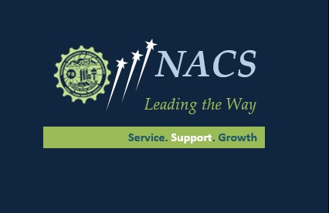

Forms - Resolution Form

See NACS Website – all resolutions are submitted electronically. Resolution Form is in the Forms Link at www.NACS-FSA.org.

Committee Survey

https://nacsfsa.weebly.com/uploads/1/5/4/2/15425262/ex_2- b_committee_survey_2017.pdf

Expense Voucher

http://members.nacs-fsa.org/members/documents/voucher2012.pdf

Membership Packet

https://nacsfsa.weebly.com/uploads/1/5/4/2/15425262/nacs_2016_members hip_packet.pdf

