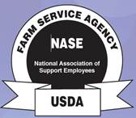

*NACS & NASE*

***2020 JOINT ZONE C & D MEETING***

***and***

***KASCOE ANNUAL STATE MEETING***

***Lexington, KY***

***February 27-29, 2020***



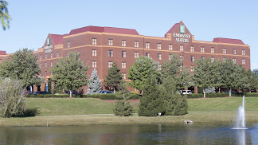

Embassy Suites

1801 Newtown Pike

Lexington, KY 40511

859-455-5000

**Please join us for the NACS/NASE 2020 Joint Zone C & D Meeting and KASCOE Annual State Meeting in Lexington, KY, on February 27-29, 2020.**

**Hotel accommodations are provided by Embassy Suites located at 1801 Newtown Pike, Lexington, KY 40511. Room rate will be $109 plus tax.**

**Embassy Suites can be contacted at 859-455-5000 to make room reservations. Please reference group code “KAC” if making reservations by phone. You may also book your reservation online using the following link:**

***Note: You must copy and paste the entire URL into your browser for it to work properly.***

<http://embassysuites.hilton.com/en/es/groups/personalized/L/LEXESES-KAC-20200227/index.jhtml>

**THE CUT OFF DATE FOR HOTEL RESERVATIONS IS JANUARY 28, 2020**

**Embassy Suites is located off Interstate 75/Interstate 64 and is only 7 miles from the Blue Grass airport and less than 3 miles from Downtown.**

**A complimentary breakfast buffet is provided by the hotel each morning in the Paddock Grille and complimentary cocktail hour with snacks & drinks provided each evening at the Manager’s Reception.**

* **Thursday night, KACS will provide a meal in the hospitality room.**
* **On Friday evening, snacks and beverages will be provided in the hospitality room.**
* **There will be a snack Friday morning and a meal at lunch on Friday.**

\*\***There will be an optional tour at no additional cost of the**

**Blue Grass Stockyards and Regional Marketplace, 4561 Iron Works Pike, Lexington, KY 40511 on Friday evening. The Blue Grass Stockyards Regional Marketplace is a space unlike any other in the country where both farmers and those with little agricultural experience can come together and enjoy central Kentucky's rich agricultural heritage and promising future. Retail shops include a farrier supply shop as well as an outdoor and western wear store. There is also an on-site restaurant and butcher shop. Hayden’s Stockyard Eatery is the on-site restaurant located at the facility that is highly recommended. Meal will be on your own.**

***Contacts:***

***KACS:*** [***vicki.swift@usda.gov***](mailto:vicki.swift@usda.gov) ***OR*** [***juanita.ballman@usda.gov***](mailto:juanita.ballman@usda.gov)

***NASE:*** [***brittany.harney@usda.gov***](mailto:brittany.harney@usda.gov) ***OR*** [***jackie.bigham@usda.gov***](mailto:jackie.bigham@usda.gov)

***NACS:*** [***nathan.adams@usda.gov***](mailto:nathan.adams@usda.gov) ***OR*** [***cheryl.brooks@usda.gov***](mailto:cheryl.brooks@usda.gov)

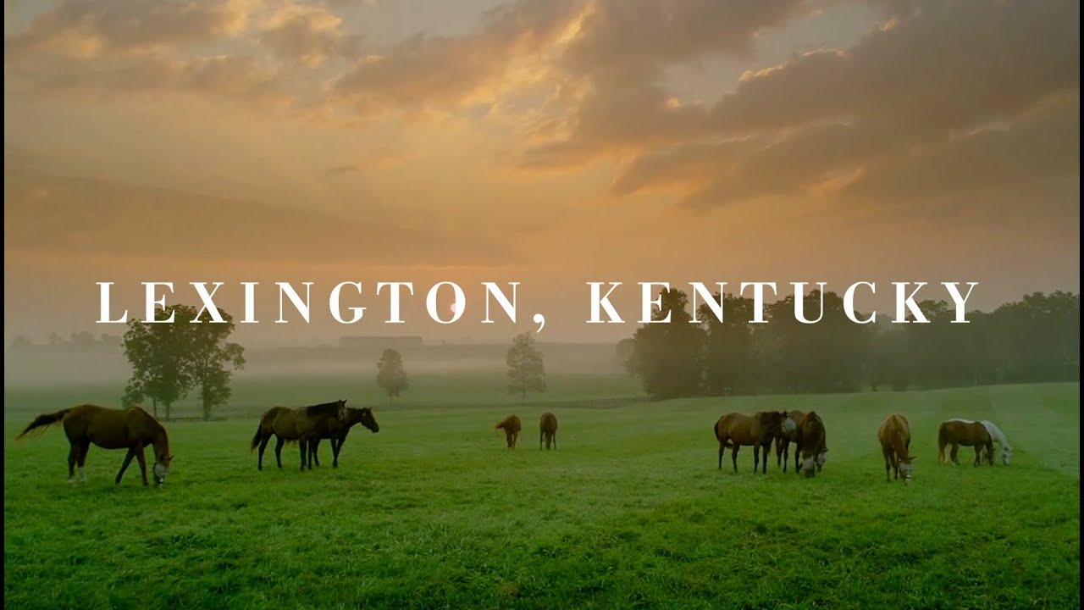

**Come for the horses, stay for the bourbon, street art, nightlife, food, shopping, architecture, history, craft beer, local coffee shops, music and the friendly people. We are ready to welcome you with our special brand of Southern hospitality.**

**Locals know it...Lexington is a vibrant city with Southern charm and hospitality. We honor our heritage of horses, bourbon and history. Traditional? Maybe. Boring? Never!**

**You can also visit** [**visitlex.com**](http://www.chattanoogafun.com) **for more information.**

**REGISTRATION FORM**

2020 JOINT ZONE C & D MEETING

2020 KASCOE Annual State Meeting

LEXINGTON, KY

**Registration is due by January 31, 2020 to avoid a late fee.**

Please mark the appropriate box: NACS-FSA 🞏 NASE- FSA 🞏 KASCOE 🞏

First Time Attendance 🞏 Retiree 🞏

Name & Title:

Guest Name:

Address:

Phone:

Email:

**Do you plan to attend the Blue Grass Stockyards tour on Friday evening? Yes No**

(For planning purposes, there is no additional fee for the tour.)

Registration fee (by Jan 31, 2020)…………………………………………….…….... $60.00 x ______ = $_________

Late registration (after Jan 31, 2020)…..…………………….………….…….…… $70.00 x ______ = $_________

Day registration fee (Friday Only) includes lunch……………………..…..…... $45.00 x ______= $_________



Make Checks payable to:

**Kentucky Association of Credit Specialists-KACS**

Mail Checks and Registration Form to:

**Nathan Denney, KACS Treasurer**

**45 Knoll Court**

**Nancy, KY 42544**



***Registration Includes: Hospitality Room on Thursday & Friday nights,***

***Friday lunch, snacks and meeting space.***