Building Rural America
National Association of Credit Specialists
of the
USDA – Farm Service Agency

INFORMATION TECHNOLOGY RESOLUTIONS

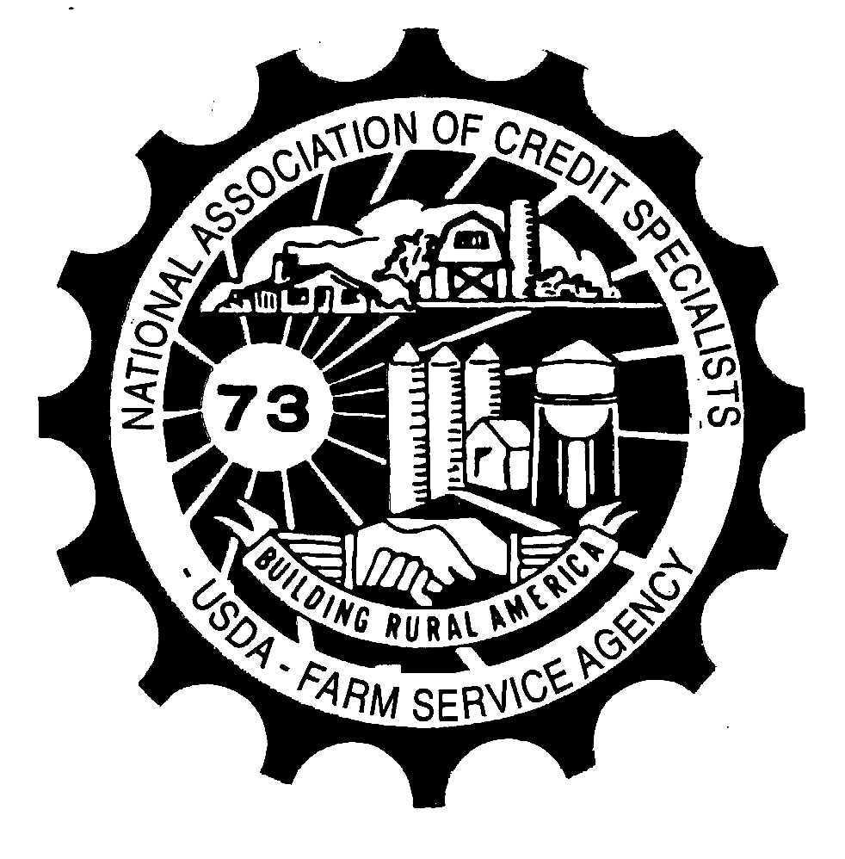

Resolution 1

CONCERN: 1-FLP Paragraph 222 L states that term limit information can be found in the customer profile. The Customer Profile is also mentioned in other handbook references regarding term limits as well. However, the term limit information in the Customer Profile for FO loans is rarely correct and the OL term limit information has many problems in providing accurate information. Incorrect information provided on this report contribute to errors and misunderstandings with producers.

PROPOSED SOLUTION: The Customer Profile calculations for the term limits need to be fixed with an enhancement to the software.

NATIONAL OFFICE RESPONSE: We currently have a ticket opened to fix this issue. However, we are currently analyzing FLP’s IT Strategy and are in the process of prioritizing automation enhancements due to our very limited budget. This will definitely be a high priority fix on the list.

Resolution 2

CONCERN: Using the GLS system to create EFTs is cumbersome and not user friendly.

PROPOSED SOLUTION: Develop an FSA-owned system or add on to an existing system for the creation of EFTs.

NATIONAL OFFICE RESPONSE: We are currently analyzing FLP’s IT Strategy and the systems involved. EFT is part of the study and we will explore ways to improve the system or develop viable alternatives to replace it given budget availability and the prioritization of other automation enhancements.

Resolution 3
CONCERN: With the deployment of the farmers.gov portal, employees have been told to use Microsoft Edge as the browser to access this site. However, other FSA programs, such as Farm Business Plan, will not function properly when using Microsoft Edge. This creates an unnecessary switching between browsers.

PROPOSED SOLUTION: Coordinate all online programs and sites so FSA employees can use one internet browser.

NATIONAL OFFICE RESPONSE: The National Office developed the farmers.gov solutions using web browsers other than Internet Explorer (I/E) as it is known that I/E will not be supported after the end of calendar year 2019. We are aware that other FSA-used software applications, such as Farm Business Plan, do not function as required in web browsers other than I/E. Therefore, a comprehensive plan is being developed to ensure that all FSA-used software applications will function as needed in other web browsers.

Resolution 4
CONCERN: Often times, the FLP forms that are provided on the form website in the DOCX format require the ability to enter multiple lines of data. To do this the restrict editing option must be stopped so that sufficient room is available. However, many people struggle with how this can be done.

PROPOSED SOLUTION: Add instructions to the employee forms website landing page on how to un-restrict editing.

NATIONAL OFFICE RESPONSE: When forms were being initially developed, as well as when revisions occur, the number of characters that could be typed in each fillable cell was considered. If the requirements for text that needs to be included in fillable cells have changed for specified forms, notify or send a list to the National Office to increase the number of characters in those cells for specific forms. The National Office is prohibited for adopting this resolution as fillable forms are locked to prevent accidental deletion of included provisions, especially on forms that evidence debt to the Government; therefore, the un-restrict editing should not be performed by users.

Resolution 5
CONCERN: Currently when reviewing borrower’s repayment history the only way to determine if payments were made on time is to pull ADPS and manually calculate when payments are made.

PROPOSED SOLUTION: In DLM customer status, add a section where it will show all scheduled payments and due dates and the date each scheduled payment is made.

NATIONAL OFFICE RESPONSE: Users should use the DLS Customer History where you are able to filter for the payment type transactions and obtain a list of all payments made to date, on a loan. Please refer to Section 8.4 Customer History, of the DLS User’s Guide, for detailed explanation of how to use this function.

Resolution 6

CONCERN: When entering a new loan into GLS, the "voluntary information" is required to be entered before you can move forward. If the information is left blank on the application (which is acceptable) then it puts the FSA employee in the awkward position of having to guess an applicant's race, ethnicity, and sex. No employee should ever be put in a position to have to make assumptions on these matters. It opens up the agency and the employee to discrimination claims.

PROPOSED SOLUTION: Include a radio button on the GLS screen for these items that says "not provided", or simply change the program so that this information can be left blank when it's not provided.

NATIONAL OFFICE RESPONSE: The National Office generally disagrees with the conclusion that this scenario would open up the Agency and/or employees to discrimination claims. The language on this section of the application form makes it clear that the applicant may not be able to receive access to targeted funds if they don’t provide the voluntary information.

That being said, RD is currently working on an overall update to the borrower screen in GLS. Based on our understanding of this RD project, the updates will include adding an option that race, ethnicity, etc., was not provided. The National Office will evaluate this resolution as RD works to implement the changes to the GLS borrower screen.

