Building Rural America
National Association of Credit Specialists
of the
USDA – Farm Service Agency

MANAGEMENT / PERSONNEL RESOLUTIONS

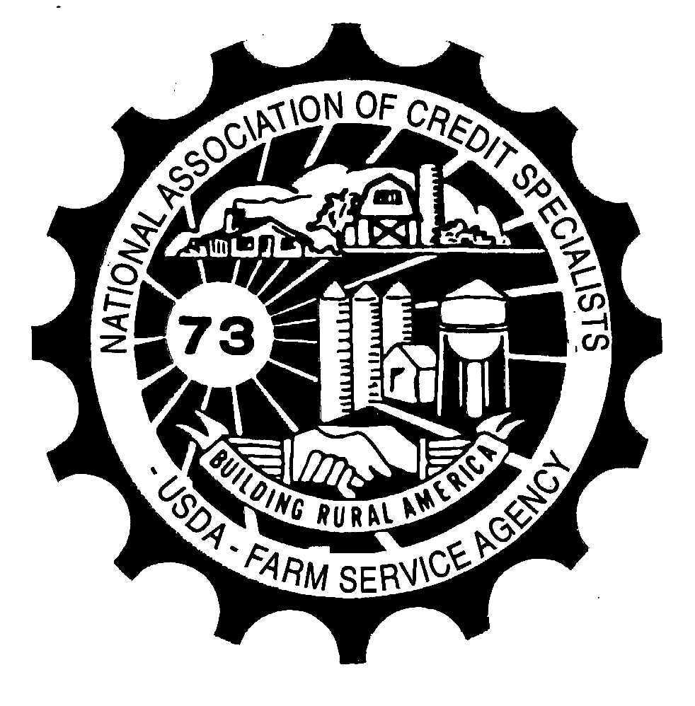

Resolution 1

CONCERN: Newly appointed Farm Loan Analysts are currently hired at a GS 9. They are required to complete phase one of the Farm Loan Officer Training program and pass the final test. In many cases, this process extends far beyond the one-year expectation, consuming the time of the trainer and those involved in the management of the FLOTRAK process. By comparison and contrast, Farm Loan Officer Trainees are expected to complete all of phase one of the training, including passing the tests before being promoted to a GS 9.

PROPOSED SOLUTION: Adjust the full performance level position description of the GS 9 Loan Analyst to include “Has completed Phase one of the Farm Loan Officer training program.”

NATIONAL OFFICE RESPONSE:

In recent discussions with states, the Loan Analyst position has been identified as a helpful one for succession planning and to increase promotion potential for current agency employees. DAFO has some concern that the proposed solution would limit the usefulness of the loan analyst position in this regard. Moreover, there is not a requirement for either position that an individual must have completed all of Phase 1 FLOT training to be hired at a Grade 9 level. The Loan Analyst position is in a different OPM job series (1101) than the FLOT position (1165) and the requirements to qualify as a Grade 9 for these series is slightly different if based on experience. All loan analysts and FLOTs, however, must complete Phase 1 of the FLOT training within 1 year per Handbook 1-FLP, Par. 25A.

For the 1101 series Loan Analyst position, an applicant must qualify on one of the bases below:
  - Two full academic years of progressively higher level graduate education or master's, or equivalent graduate degree (LLB, JD, LLM, Ph.D., etc.), from an accredited college or university with a major in finance, business administration, economics, accounting, engineering, mathematics, banking and credit, law, statistics, or another field related to the position such as agriculture, agricultural economics, farm, livestock, farm management, ranch management, rural sociology, dairy science, domestic agricultural development or agronomy; OR
  - One full-time year (12 months) of specialized work experience equivalent in difficulty and responsibility to the GS-7 level in the Federal service. Experience that demonstrates knowledge of credit principles and practices to assess the fundamental soundness of loans by independently examining applications, supporting documents, and credit reports, and maintaining servicing activities on agricultural loans. In addition, experience applying analytical and evaluative techniques to assist in assessing the effectiveness and efficiency of farm loan program operations to make recommendations for improvements; OR
  - A combination of education and experience as listed above.

For an 1165 series FLOT position, an applicant could similarly qualify based on education, but the experience requirements are slightly different. Often these positions are advertised at a full performance Grade 11 level.
  - Two full academic years of progressively higher level graduate education or masters or equivalent graduate degree from an accredited college or university with a major field of study in finance, business administration, economics, accounting, engineering, mathematics, banking and credit, law, statistics, or other fields related to the position, such as agriculture, agricultural economics, farm, livestock or ranch management, or rural sociology; OR
  - Applicants must have one year of specialized experience equivalent in difficulty and responsibility to the GS-7 level in the Federal service or private sector equivalent. Experience that demonstrates competence in agricultural loans. Experience may have been gained in such work as reviewing and passing upon applications for agricultural loans; servicing an agricultural loan portfolio of a bank or other loan association; or similar work. Experience that demonstrates knowledge of credit principles and practices to assess the fundamental soundness of individual loans by independently examining applications, supporting documents, and credit reports, and maintaining servicing activities on small agricultural loans. In addition, experience must demonstrate knowledge and understanding of farm operations, land use and value, production of various crops and livestock, and prices and markets in the farming area where loans are made and serviced; OR
  - A combination of education and experience as listed above.

Resolution 2

CONCERN: Many NRCS offices have government issued cell phones for use when completing field work. FSA does not have similar phones. The use of these phones would be extremely beneficial to loan officials completing farm visits so personal cell phone numbers are not provided in the event that calls to customer are necessary for schedule changes, etc.

PROPOSED SOLUTION: Provide 1 cell phone per FLP duty station for Farm Loan teams to share as related to field duties.

NATIONAL OFFICE RESPONSE: FSA is in the process of reviewing the current policy regarding mobile devices and hope to have a revised policy in place by the summer of 2020.

Resolution 3

CONCERN: Currently there is management or leadership training for all sectors of our FSA employees - both GS and CO - with the exception of Farm Loan Officers.

PROPOSED SOLUTION: Implement a leadership training program available through application for Farm Loan Officers and Farm Loan Specialists who desire to attain additional leadership skills.

NATIONAL OFFICE RESPONSE: There is nothing currently in the works for leadership training for FLO’s and FLS’s, however, DAFO will look at its feasibility for the future.

Resolution 4

CONCERN: New Farm Loan Program PTs are starting their jobs unable to perform the duties required. Farm Loan Managers and Farm Loan Officers do not have the time nor ability to adequately train new PTs.

PROPOSED SOLUTION: The Creation of a formal Farm Loan Program PT training program similar to the FLOT program via the national Office with set structure, goals, case studies, and mastery requirements.

NATIONAL OFFICE RESPONSE: In summer 2018, the National Office conducted a survey to gather information on areas PTs need to obtain training on to fulfil their responsibilities. Based on the responses we received, we are currently in the development phase of a formal Farm Loan Programs PT training program. We expect to make available the first job aids mostly requested by the end of calendar year 2019.

Resolution 5

CONCERN: The workload analytics reports that had been prepared and provided to the states which converted all the program & activity coding in WEBTA to a digestible format. The basics of this information is a major component of the OPO (Optimal Productive Office) which is the staffing tool currently being used. However, the workload analytics report is no longer being made available. This is a concern as this report provided very digestible information to help the supervisors and managers ensure that the employees were / are codding all their time correctly.

PROPOSED SOLUTION: Although the entire report may no longer be needed, at a minimum the portion that provided the overall summary of hours as compared to work units is very beneficial to all the offices. A portion of the data can be obtained currently from OBIEE (hours reported by program/ activity); however, it is not in a format that is digestible as it is the hours reported. Have DAFO bring at least that portion of the workload analytics report to the FLMs, DDs, and CEDs so that we can all better monitor this information.

NATIONAL OFFICE RESPONSE: The Workload Analytics report is still be used and updated on a regular basis. The last update of the report was on December 10, 2019 and was distributed to all State Office Workload Liaisons so that they could be distributed to all county level managers (CEDs, FLMs, SFLOs). All States were required to complete training on the product and distribute it to local managers by October 31, 2019.

FSA has requested a Tableau license for every county level manager and once the acquisition is completed, ideally in the 2nd quarter of FY 2020, managers will have direct access to the Workload Analytics report from the FPAC Analytics website.

Resolution 6

CONCERN: Newly appointed District Directors who do not have Loan Approval Authority are immediately enrolled in the Farm Loan Officer Training Program. In many cases, District Directors languish for a significant period of time beyond the timeframe specified in 1 FLP prior to receiving their loan approval authority.

PROPSED SOLUTION: Adjust the performance plan standards in the Supervision Element for a Supervisory District Director to include “Has completed Farm Loan Officer Training Program in accordance 1 FLP Paragraph 25”.

NATIONAL OFFICE RESPONSE: According to information available through FLOTrack, most trainees complete the training within the allotted timeframes. As DDs have expanded responsibilities for both Farm Programs as well as Farm Loan Programs, there has been instances where DDs take additional time to complete the FLOT training.

Resolution 7

CONCERN: The Vehicle Management Tool is creating some issues in field offices with scheduling vehicles because the local managers cannot see the schedule of the vehicle and who has it reserved. This leads to inefficiencies in trying to schedule a vehicle and having communication regarding the most efficient use of the vehicle, i.e. who will be travelling the furthest, who could most effectively use which vehicle and timing scheduling around vehicles, as well as access to the keys.

PROPOSED SOLUTION: Provide local managers who are responsible for the vehicles in the Service Center access to the schedules for the vehicles, as well as an email notification when a vehicle has been scheduled, in order to allow them to more efficiently schedule the vehicles, know when they will or will not be available, and to facilitate access.

NATIONAL OFFICE RESPONSE: Part of the proposed solution has already been implemented, and part of it will be implemented in the future. Managers can currently view a calendar schedule for all of the vehicles in their office. This calendar displays all the reservations that have been made for a particular week in a particular office. To view this calendar in the VMT, please follow the below steps:
- Make sure to use Google Chrome as your browser when using the VMT.
- At the VMT Home Screen, click “Reserve a Vehicle”
- Enter a pick-up date and time and a drop-off date and time. The times entered should coincide with the timeframe the user is interested in seeing on the calendar view
- Click “Search by Location”
- Enter the office location
- Click on “Check Weekly Availability”
FPAC-BS is working on ways to make this calendar view easier to access for VMT users.

The solution also asks to have the VMT generate an email to the local manager or vehicle custodian whenever a vehicle is reserved. This VMT enhancement is on the list of actions to be worked by the contractor who is supporting the VMT. We expect to implement this enhancement in the coming months. We will provide more information to the field when we have a better idea of when the enhancement will be fielded.

