Building Rural America
National Association of Credit Specialists
of the
USDA – Farm Service Agency

LOAN MAKING RESOLUTIONS

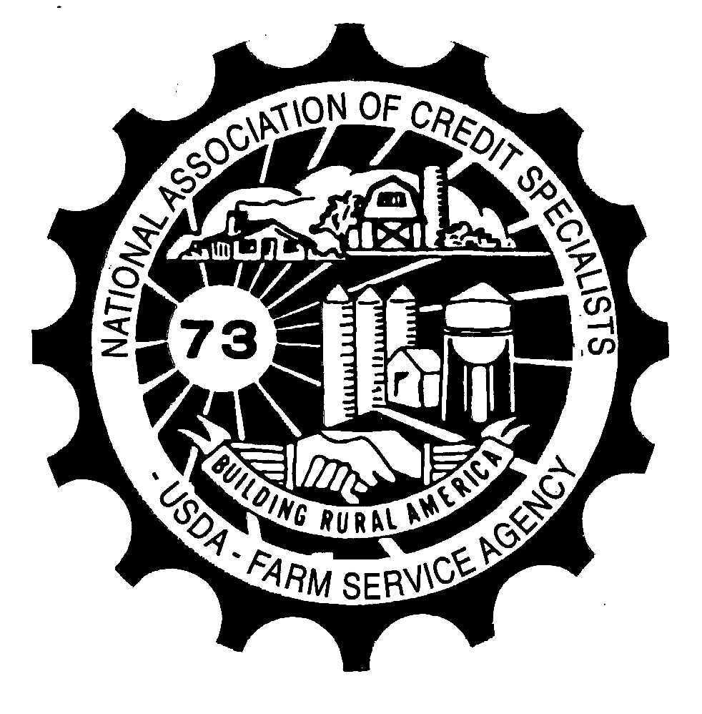

Resolution 1

CONCERN: Loan officials are unable to determine ineligible loans that exceed their approval authority.

In our area we have a much higher FO rate than other loans and they tend to be above the FLM limits. This means that when we need to deny applications (usually for eligibility issues) we have to send the file to the State Office and can only "recommend denial" in the field office. This adds on a minimum of 4 days (but up to 2 weeks in one instance) on to timelines which negatively impact the office's goals as well as add on unnecessary work for both field and state office staff. There should be no need for the State Office to review a denial because field staff are more than qualified to assess the eligibility on all files.

PROPOSED SOLUTION: Allow field staff to deny applications at any dollar amount based on eligibility for any type of loan.

NATIONAL OFFICE RESPONSE: The National Office understands the potential frustration and delays that sometimes arise while awaiting state office concurrence of uncomplicated application denial decisions. However, this process cannot be changed as OGC has indicated that a loan official cannot deny a loan that they are not allowed to approve. With that said, states are encouraged to evaluate their state office application review methods to determine if an expedited process can be implemented for certain requests (i.e. remote FBP reviews).

Resolution 2

CONCERN: Having to enter the dollar amount and year for every single program on form CCC-36 (Assignment of Payment) & CCC-37 (Joint Payment Authorization) is inefficient and could lead to borrowers who are less than 90 days past due getting program payments.

PROPOSED SOLUTION: Improve the assignment/joint authorization form to be able to take a blanket assignment on all programs.

NATIONAL OFFICE RESPONSE: The FPAC-BC Assignments and Joint Payments section is in the process of issuing an FI notice and an updated CCC-36 to address the concern.

Resolution 3

CONCERN: The instructions for completing the FSA-2313 form are not complete which leads to the form being completed differently and incorrectly.

PROPOSED SOLUTION: Revise Form FSA-2313 (Notification of Loan Approval and Borrower Responsibilities) to be easier to understand and provide more detailed instructions regarding the completion of the form.

NATIONAL OFFICE RESPONSE: The National Office agrees with the recommended changes to the FSA-2313 and is currently working on changes to both the form and to the instructions.

Resolution 4
CONCERN: When entering a new GL into GLS, it requires separate input of interest and principal repayment frequency. On the FSA-2211 and 2212 it only has one place for "Repayment Frequency" and does not split it out. Without prompting, most lenders will just put the principal repayment frequency even when it differs from interest.

PROPOSED SOLUTION: On the FSA-2211 (Application for Guarantee) and FSA-2212 (Preferred Lender Application for Guarantee), split the "Repayment Frequency" box into interest and principal to match GLS data entry requirements. This will prompt lenders to give us the required information to eliminate follow-up calls.

NATIONAL OFFICE RESPONSE: The Guaranteed Loan Making Branch will host a taskforce to review and recommend changes to all forms related to guaranteed loan making. This suggestion, along with others, will be presented to the taskforce.

Resolution 5
CONCERN: Requirements for a complete DOL-ML application include verification of all non-farm income relied upon for repayment, but the application doesn't ask for the employer's name and contact information.

PROPOSED SOLUTION: Add the line items to the form.

NATIONAL OFFICE RESPONSE: The National Office agrees that a clarification to the handbook language is warranted. The change will be put into an upcoming amendment to indicate that if non-farm income is needed for repayment, that verification will be done via pay stubs. Only in those cases where that is not possible should an FSA-2014 be sent to the employer. This change should allow FSA to obtain the necessary information without changes to the form.

Resolution 6
CONCERN: 11c of FSA-2026 form instructions states "For Farm Ownership loans and loan restructures, no more than 12 months may be used between the restructure closing and the instalment due date." This instruction actually does not appear in the handbook.

PROPOSED SOLUTION: Incorporate the form instruction language into 3 FLP paragraph 135c for clarity.

NATIONAL OFFICE RESPONSE: The National Office will modify the handbook language to clarify that the first installment must be scheduled within 12 months of loan closing for Farm Ownership Loans.

Resolution 7
CONCERN: Maximum Loan Authorities as outlined in 1-FLP, paragraph 29 (D) were recently revised in Amendment 181. Execution of the table outlined in paragraph 29 as written and following the example is resulting in an excessive number of loan requests being forwarded to our State Offices, overloading our State Farm Loan Specialists and Farm Loan Chiefs. The main concern lies in the interpretation of Limitation I, which requires both new and existing loans be counted in this limitation. The example given immediately above the chart (Paragraph 29D ) requires that a $100,000 direct OL loan request be sent to the State Office because the borrower has an existing $600,000 direct FO loan. Even if the direct loan request is a small $10,000 microloan, this example would require that the loan request be sent to the State Office for approval.

PROPOSED SOLUTION: Revise the paragraph and example to state that Limitation I refer only to the loan request or combination of requests. Then Limitations II, III and IV would include existing loans plus the new loan request or requests.

NATIONAL OFFICE RESPONSE: The National Office understands that this issue has caused additional workload on State Offices, and potential delays in approval times. However, basing approval authority on the total dollars at risk is more in line with industry standards and provides additional oversite for borrowers with large debt loads. The National Office is currently reviewing methods to clarify and improve this process.

Resolution 8
CONCERN: The loan approval timeframe goals for both DL and GL are calculated from date received instead of date of complete application. Getting the information to make an application complete is many times outside of the FSA loan official's control. We can request the information from the applicant and/or lender but we cannot force them to provide it in a timely manner. We should not be held accountable for things outside of our control.

PROPOSED SOLUTION: Calculate loan approval timeframes from the date the application is complete, for both DL and GL.

NATIONAL OFFICE RESPONSE: The National Office led a taskforce that evaluated and recommended updated FLP goals for 2020-2024. One of the changes suggested and adopted is to alter the processing time goal methodology to exclude applications that are withdrawn within the timeframes established in 2-FLP and 3-FLP. Updated goals for the upcoming 5-year period have been issued in Notice LFP-805.

Resolution 9
CONCERN: The use of risk-based pricing varies a lot from lender to lender, and even from loan to loan within the same lender. Therefore, to meet the documentation requirements, we have to request this information every time. The lender has no good way to know to provide this information ahead of time, unless they are an experienced GL lender and have just learned over time.

PROPOSED SOLUTION: Include a section on the FSA-2211 (Guaranteed Loan Application) and FSA-2212 (Preferred Lender Guaranteed Loan Application) for the lender to state whether or not they used risk-based pricing on that loan and if so, to certify that they are offering the borrower one tier lower than they would have gotten without the GL.

NATIONAL OFFICE RESPONSE: The Guaranteed Loan Making Branch will host a taskforce to review and recommend changes to all forms related to Guaranteed loan making. This suggestion along with others will be presented to the taskforce.

Resolution 10
CONCERN: The job of completing Environmental Assessments has fallen largely on FLP loan officials. This burden falls upon loan officials, who are already over-burdened. This process has loan officials who are primarily financial experts, preparing Environmental Assessments. Environmental Assessments being completed by individuals with minimal training and no specific expertise in the field, exposes the Agency to unnecessary litigation risk.

PROPOSED SOLUTION: Work with our FPAC sister agency, NRCS, to complete Environmental Assessments. They are experts in the field and have personnel in almost every USDA office who are better trained and could complete the work.

NATIONAL OFFICE RESPONSE: The FPAC-BC-ENV staff agrees that loan officials may not necessarily be well prepared or positioned to complete Environmental Assessments. NRCS is well versed in conservation programs and some aspects of NEPA environmental compliance but also faces challenges related to their mission area. Recognizing there is a need for collaboration, the FPAC-BC-ENV has formed an FSA-NRCS Task Force to examine these issues and have already presented a series of proposals to leadership. They were largely receptive, and we hope to soon be able to move forward with next steps for implementing those which be of the greatest benefit.

Those states with a large environmental workload also have the option to use of a Full Time SEC position, with an incumbent selected based upon related qualifications and experience. This practice provides for efficiency of process as well as an improved work product. In addition, FPAC-BC-ENV has been authorized 3 Regional ENV Coordinator positions and interviews are in process for two of these positions. A NEPA Program Manager has also been recently added to the ENV staff and is available to assist states with complex NEPA issues.

Resolution 11
CONCERN: The FSA-2302 (Description of Farm Training and Experience) and the FSA-2370 (Request for Waiver of Borrower Training Requirements/Borrowers Training Assessment) are somewhat repetitive. Our DL application is already several pages long, and streamlining it in any way would be beneficial to both FSA and the applicants.

PROPOSED SOLUTION: Combine the FSA-2302 (Description of Farm Training and Experience) and the FSA-2370 (Request for Waiver of Borrower Training Requirements/Borrowers Training Assessment) into one form that gives the applicant the opportunity to list education/training/experience and to request a waiver of borrower training requirements. Include a section for the loan official to approve/decline the request.

NATIONAL OFFICE RESPONSE: These forms have different purposes and are utilized at different times in the application process. The FSA-2302 is part of a complete application and information on it should document the experience and training an applicant possesses when they apply for a loan. The FSA-2370 is required specifically to document Borrower Training requirements, including if the applicant needs training. The form may also be used to determine if a prior waiver of training remains enough for the new loan. The FSA-2370 is not received at the time of initial application as Borrower Training requirements should be determined only after reviewing a complete application.

